October 2016

Bradley Birch, Josh Cronin, Tanya Stittle, Matthew Fergusson-White, Stefan Vaughan

Chata

Chata Application

Development Documentation

Contents

Design Principles 3

Designs 4

Initial Designs 4

Design Feedback 8

General 8

Login Screen 9

Sign up 9

Chat 9

Profile 9

Final Designs 9

11

11

Testing 13

References 17

# Design Principles

A high quality website is something that users appreciate and will subsequently return too. High quality websites are obvious and self-explanatory. It is easy for the user to get around the site and make use of all its features; regardless of the device, they are on. They are interesting and immediately grab the user’s attention. Finally, they are useful and provide value to the user. When creating a website it is important to bear these concepts in mind. This section details these concepts and how they have been considered for our web application.

Usability is an attribute that looks at how easy a user interface is to use (Nielsen, 2012). If a website is hard to use or difficult to understand, users will not use the site. A website must be easy to learn and quick to use. The site should be clean and simple to understand. User should enjoy using the site and not feel frustrated by it. This should be true for all types of users from beginners to power users and we should cater for their individual needs. Usability is a massive consideration for our application. We need to make sure that people understand what our application is and how it works but at the same time not over-simplifying it. Users should be able to login to the site and instantly understand the sites aim. Without these aspects of usability, we will not retain users and find it difficult to gain new ones.

A successful UI (user interface) needs to be engaging. An engaging UI will flow, be compelling and is a pleasure to use. A UI that doesn’t flow will see users bounce for example, a multi-step signup process that doesn’t make navigation obvious will most likely see users completing the first step but then dropping off because they cannot see how to progress. As well as being able to easily navigate through the UI, it will also have to be something that users want to use. You have to ensure the UI matches the target audience and works without issues. Creating a compelling UI merges with creating a UI that is a pleasure to use. Interfaces that are a pleasure to use will be aesthetically pleasing, easy to use & understand and respond to users’ actions. These properties should be considered during the design process of any UI.

Accessible design is a major key to enable a web application to be successful. It allows stakeholders to target all of the intended users, by designing the product to meet their needs. This concept is produced to ensure all types of people are targeted and not just a specific group, meaning it would enable people with disabilities to use the web application without any difficulties. The user interface will need to be flexible, so that it has the ability to accommodate a huge variety of users and meet their preferences. Inputs within the application will make it simple for the users to fill out; for example, if their phone number was requested on sign up, the keypad provided would show numbers instead of letters. Simple tweaks can make a big difference.  
There are a set of Web Content Accessibility Guidelines to ensure that the content on an application meets the accessibility standards for the web. There is a selection of tests that can be checked against the application once completed to ensure that the accessibility of the chat is to the highest quality.

When creating a design for an application, stakeholders should ensure it is rewarding for clients. This ensures clients stay motivated to use the application and lets them know they are doing something right. It makes the application more enjoyable to use, will engage the target audience and most importantly will encourage the user to return. Some examples of a rewarding application could be achievements for using certain functionality or even well designed animations for completing something. Adding small features like this can make a huge impact on an application and will result in more users, a high standard application and most importantly the page being a success. A realistic example of a rewarding design principle for the Chata application would be unlocking a certain profile image once the user reaches one hundred messages to friends.

Some other considerations when designing an application include ensuring that the user feels like the content they are seeing is relevant and up to date. Making sure to use the right controls to capture data from the user to reduce complexity when they are providing information in the application. Ensuring that the pages are able to cope with different displays. These are crucial to ensure the user gets a seamless experience regardless of the device they are using to access the application. Additionally, the page should be copyrighted in order to stake ownership over the website and use of media such as sound and animation should be carefully considered in order to prevent the user becoming annoyed. Use of this media can also cause the page to load slower.  
A final consideration is the data protection act, users are protected online from the misuse of their data, therefore it is important adhere to legal principles put in place to protect users and also to ask the user’s permission to use their data and ensure that it is made clear what the user’s data will be used for.

In conclusion, design principles are essential in web development and every detail matters however big or small. Clients will notice every feature and will very quickly get an idea on how much effort went into the application. This will make clients instantly make a decision on whether they would like to revisit the site at another date, recommend it to a friend or simply leave the site and never return, therefore demonstrates how important this segment is. By ensuring this section is very well created, it will support a strong and successful future for the project, which both creators and clients will find it engaging, rewarding, accessible and usable.

# Designs

## Initial Designs

The project will be optimised for mobile and the application will respond to different screen sizes. We have identified the following requirements for the project.

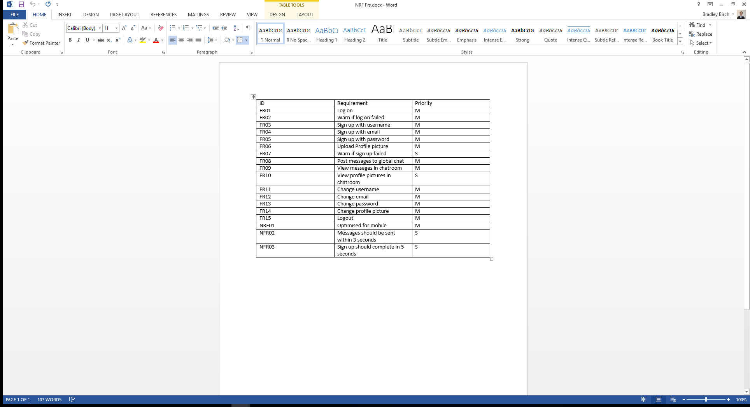

Figure : Project requirements

With these requirements in mind, we have created the following designs.

**Mobile**

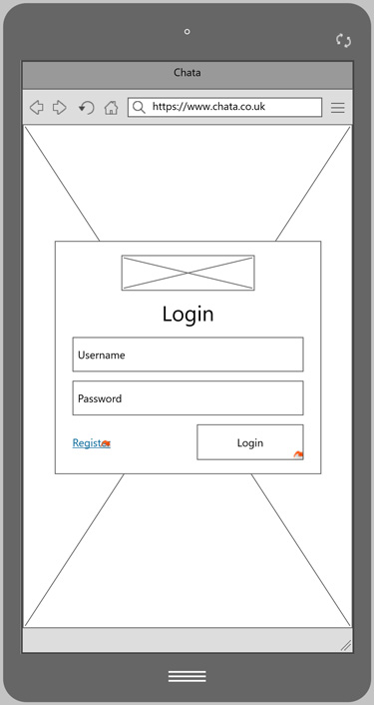

* Minimal input so that virtual keyboard does not cover any fields
* Validation will colour the input box and a message will occur above the fields
* Button to navigate to the sign up screen
* Large call to action button to login

Figure 1: Login screen

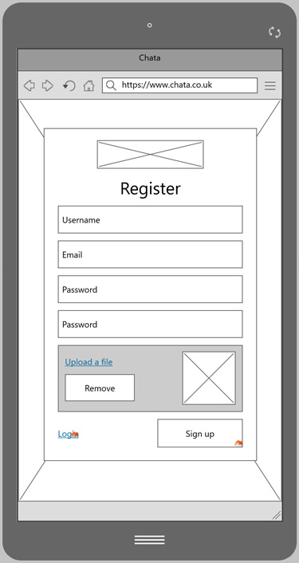

* Minimal fields to sign up
* Password confirmation box
* Validation will colour the input box and a message will occur above the fields
* Button to navigate to the login screen
* Large call to action button to sign up

Figure 2: Register screen

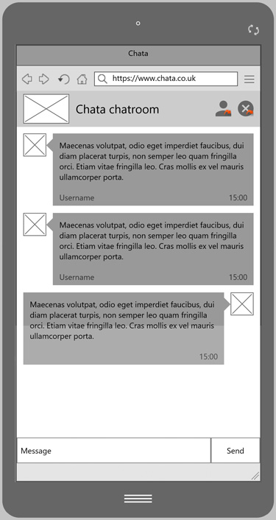

* Top inline navigation bar takes you to profile page and logout
* Clean page with little clutter allows for an easy user experience
* Users can see the profile pictures of different users
* Clear input and send button
* Message failure message will occur as a pop up above the send message

Figure 3: Chatroom screen

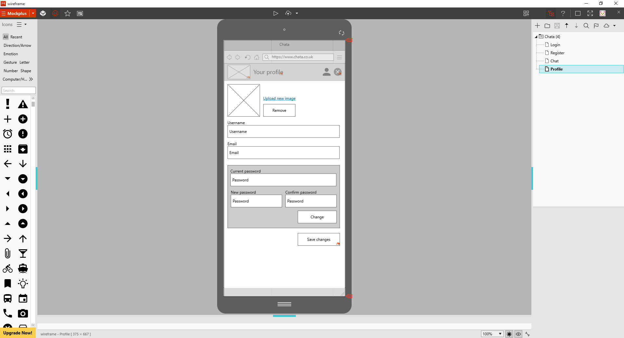

* Top inline navigation bar takes you to chat and logout
* Validation will colour the input box and a message will occur above the fields
* Save will return you to the chat room
* Minimal amount of fields

Figure 4: User screen

**Desktop**

The wireframes for desktop are very similar to the ones for mobile. The enhanced screen size allows extra space on the page, meaning more flexibility for content on the application. The majority of the functional requirements needed for the application are already explained in the mobile wireframes as we are following mobile first design, so the desktop ones are quite self-explanatory. The additional elements added will be explained below. There are minor notes below reflecting any differences between the two device sizes.

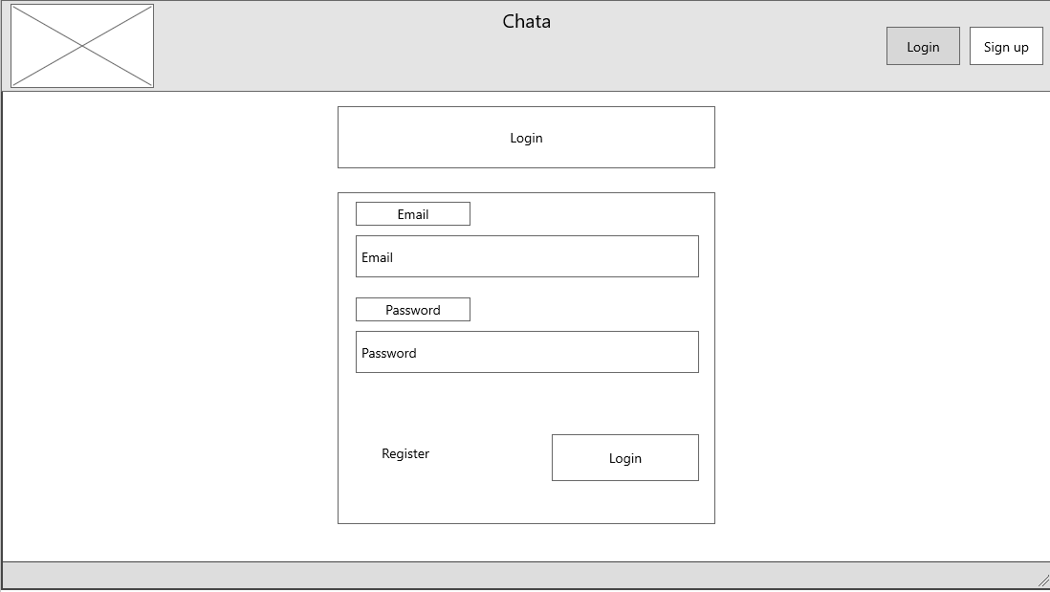

Figure 1: Login screen

* The sign up and login buttons are duplicated to the top nav to give the user a choice. The rest of the login form is in the same format as it is on a mobile device.
* Labels have been added due to the additional room on the page, meaning the option of using a placeholder attribute in mobile can be removed from the inputs.

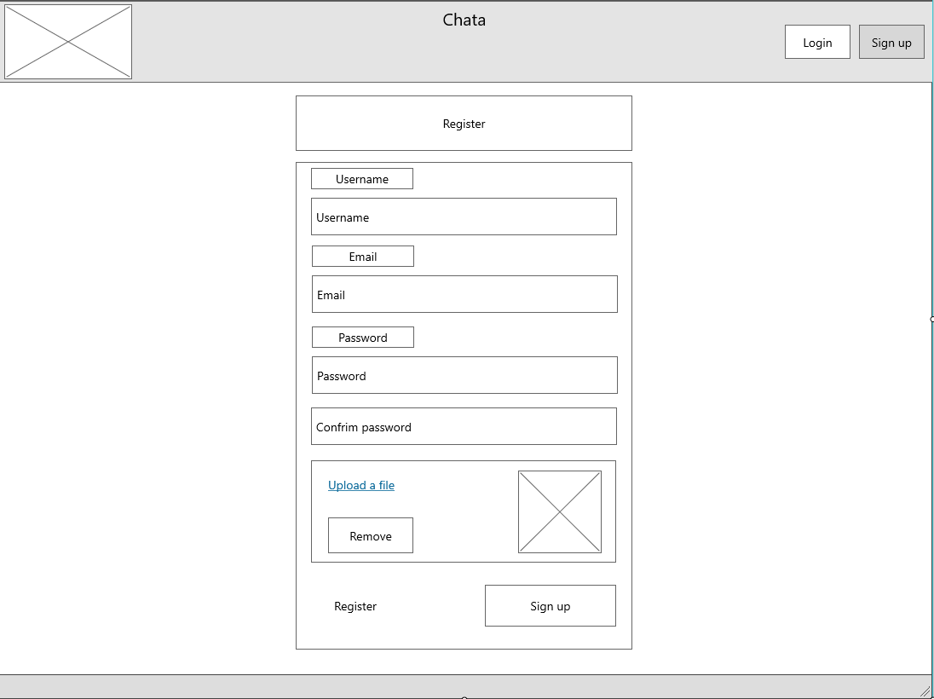

Figure 2: Register screen

* The layout is again similar to mobile. No additional functionality is added at this point

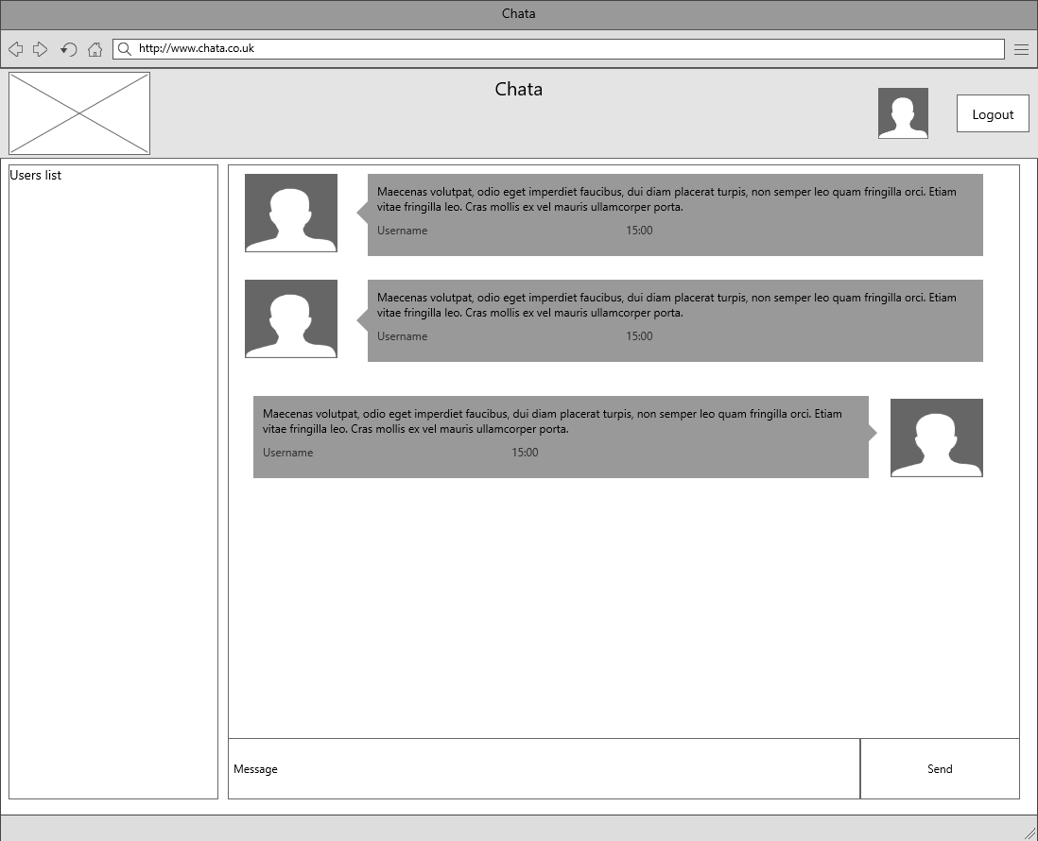

Figure 3: Chatroom screen

* The extra size allows there to be a user list. Displaying application users.
* The icon along the top navigation that takes you to the live chat will change to a slightly bigger version.

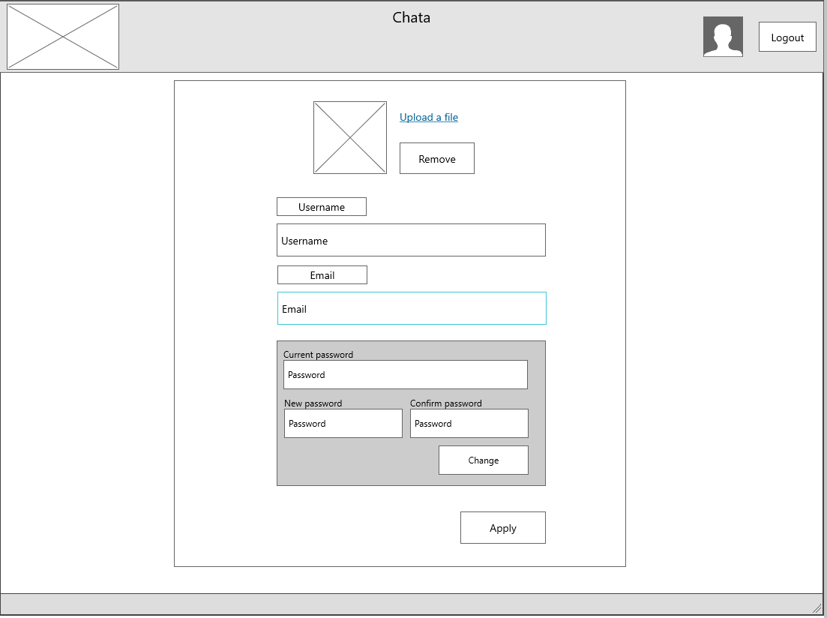

Figure 4: User screen

* Similar to the mobile version, the navigation bar will still allow you to log out and view the chat.

## Design Feedback

Overall, the feedback for the designs was positive and there were only minor issues.

### General

One of the main concerns was that on mobile there is placeholder text with no label on all of the input fields. This may be confusing for the users when entering their information. Subsequently, we have amended our designs so that every input field has a label regardless of if it is mobile or desktop.

### Login Screen

Feedback for this was strong. Generally, simplicity works well as it shows the full range of the functions. It was suggested that we add functionality to reset a password but this is outside our minimum viable product.

### Sign up

The sign up process should be as frictionless as possible. By having a picture upload this might make it harder to sign up. People may not want to add a profile picture and this may put them off signing up. The current design certainly has this issue. This could be improved by making it clear to the user which fields are mandatory or not. This would convey to the user that you do not need a profile picture and make signup much easier.

### Chat

The feedback we received was that there is extra functionality on the web wireframe than there is on the mobile. This could cause minor issues if a user would like to see the users list but are limited to a mobile device. However, we do not have enough space and at mobile sizes it is simply impractical to show users list. It could be difficult for a user to distinguish between other users in the chat, as there is no other indication apart from the display picture to show who they are. To amend this we will display the username of the users.

### Profile

The new password and confirm password inputs may be too small to fit the user’s full password in when on a mobile device. Having them on separate rows, making them full width would then stop this from happening. Overall though Simplicity works well, allowing no confusion or uncertainty.

Overall feedback was strong for our designs. There were minor issues and these have been addressed. In our evaluation, we utilised different resources. We used MockPlus are creating out wireframes and addressing issues. This allowed us to compare different designs and see which option was better. We used email to confer with our colleagues and get the actual feedback. Finally, we used google to search for example apps and understand what current solutions are.

## Final Designs

Before starting the design of the mockups, we made sure we were clear about any issues from the design of the wireframes which may have left an impact if we didn’t address them immediately. As time was limited, we were unable to reproduce further developed wireframes, so we implemented the changes while building up to our final design.

We started with a colour palette of: 

We then continued to investigate other successful chat apps, to understand the look and feel that’s received once the app is first opened. Our aim was to enable our users to feel comfortable and calm from the time that they enter the app, until the time they leave; this feeling has been reflected by the gradient colour of blue to green. Staying away from harsh and sharp colours was ideally the route to take, focusing on more mellow and subtle tones.

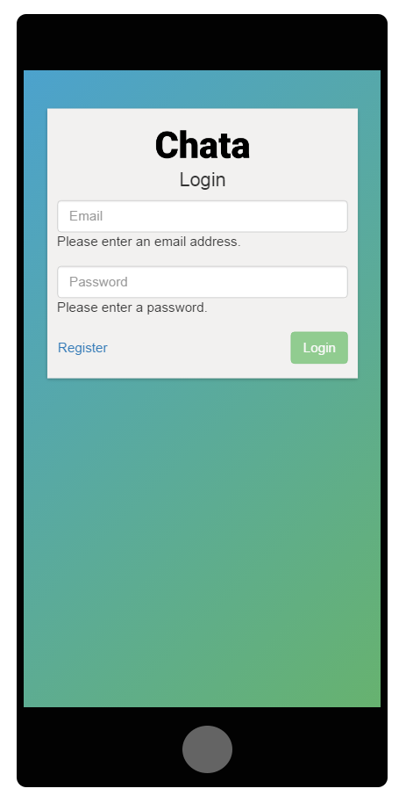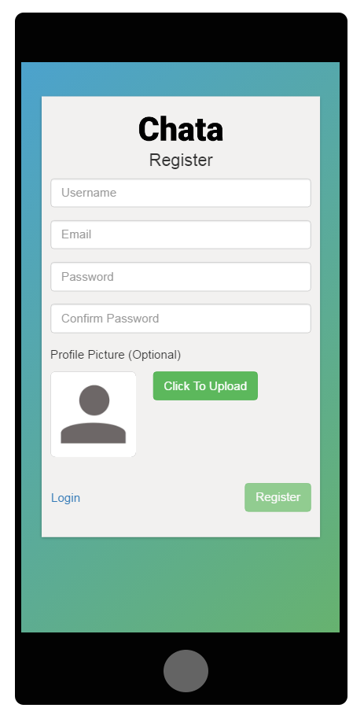

To keep everything at a minimum, we removed the top nav as it was performing the same action as what we have now.

The positioning of the profile picture is styled and positioned identically as on profile page to maintain consistency.

### C:\Users\vaughanst\Documents\GitHub\chata\Documentation\Design - Task 2\Mockups\m-chat.pngC:\Users\vaughanst\Documents\GitHub\chata\Documentation\Design - Task 2\Mockups\m-profile.png

### 

Taking feedback into account, the new and confirm password inputs were repositioned, making them sit on separate lines. This will help general usability making sure the password fits within the width of the input.

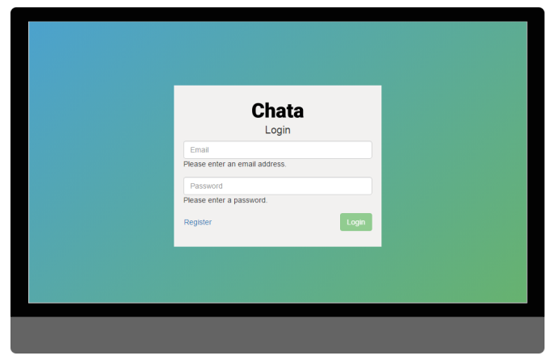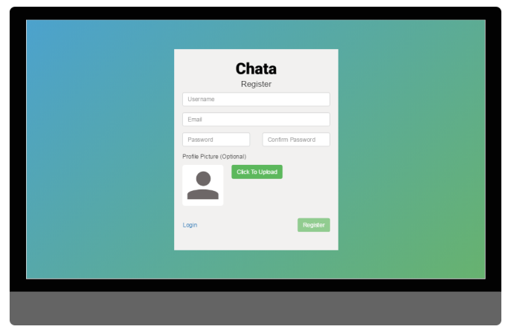

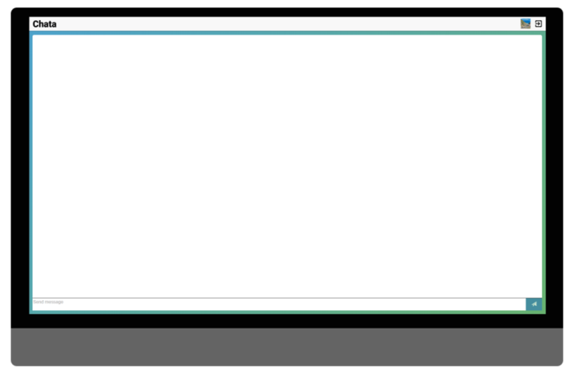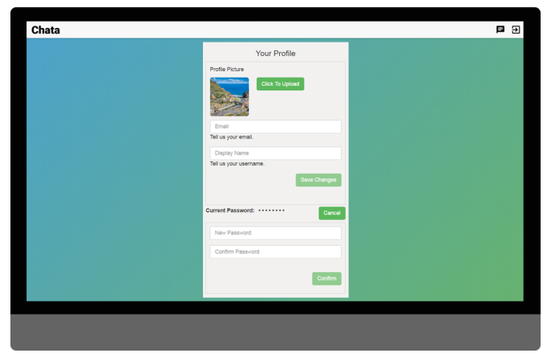

As time was short, we realised that we may struggle to develop the user list at desktop size on the initial release, so we decided to remove it and plan for it at a later date.

To create these wireframes, we used Photoshop. This was a good option as it gave us the freedom to experiment with positioning, images, colours and shapes. We were then able to get an idea of what worked well, against hat didn’t.

# Testing

This test plan is designed to fully test the functional and usability requirements of the chata app.

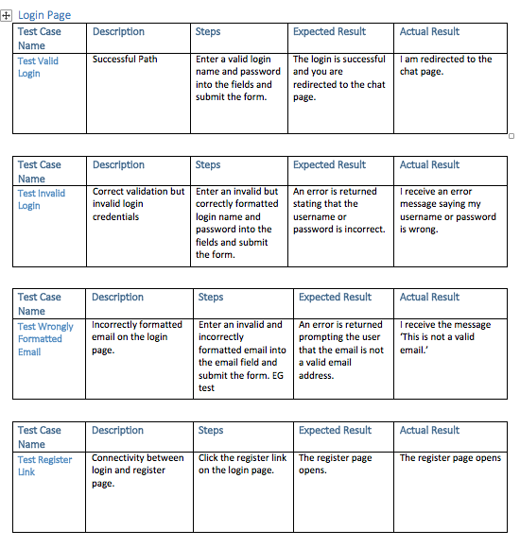

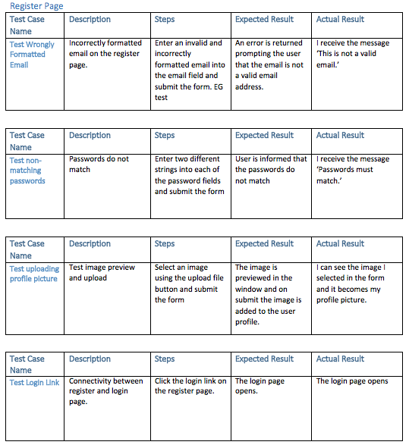

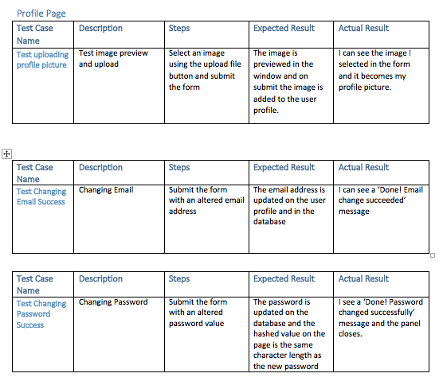

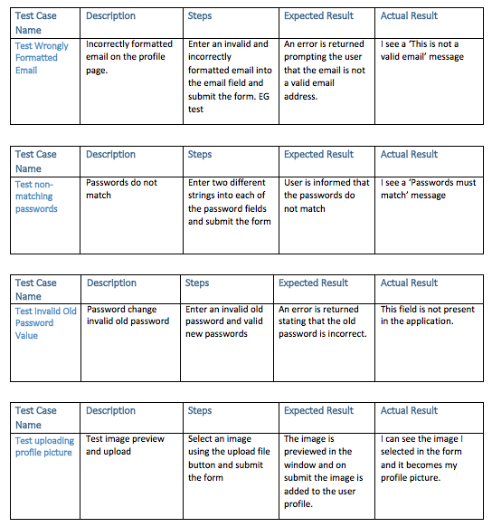

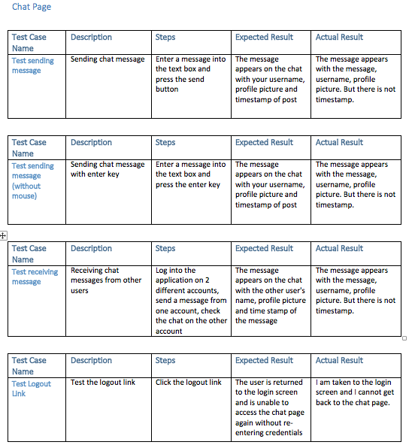

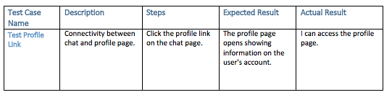

# 

## Test Review

The main aim for the test cases were to trial all of the applications funnctions to review their outcomes were as we expected them to be. The results came back exactly as we thought, meaning we had the results we were looking for.

The tests passed as we added each requirement clearly into the initial prototyping, allowing us to have a clear view of what was needed to be done through the development. Then creating highly relevant test cases helped us make sure nothing was unintentionally missed out or forgotten about. This is a key factor in making sure the product is successful in meeting the requirements due to how easy it can be to forget to implement certain functions.

The development happened very rapidly, but from the beginning we made sure that we planned well to meet the requirements of the application and had a clear idea of the tests we may have needed to run, before we entered the development or testing phase.

As stated, all of the requirements were met. We started by implementing the functional priorities, and then focused on the lower level ones. From here, we then moved onto the non-functional requirements. This allowed us to get the foundation built functionally and correctly, to enable us to concentrate on the user interface. Undoubtedly, we did go back and check the system over while building, as this helped us ensure everything was in check ready for actual testing.

## Feedback

When we asked for feedback on our application the reaction was generally positive, we were praised on the way that the application handled unexpected inputs and for the general simplicity of the app and the way it is presented. The reviewer was particularly impressed by the flexibility of the chat part of the web application which was able to handle complex inputs and large amounts of inputted data.

The reviewer suggested that the image uploaded needed some further validation or feedback implemented to help the user understand what was happening when they choose to upload a picture, if we had further time we would have implemented a progress bar to update the user on the upload of their image and feedback on the success or failure of the upload to the user to ensure that they haven't moved onto the next step before their profile picture upload has succeeded.

Another piece of feedback was that while horizontally the page flowed well, the vertical orientation of the page didn't scale when you made the chat page smaller therefore making it difficult to use the chat application without having the page full screen. A potential improvement would be to make the chat area capable of using a compacted view similar to the way that the mobile interface worked to make the interface scale correctly with the browser window.

The final piece of feedback received was that while the validation was working correctly it was not always clear to the user when it appeared, generally due to the fact that the text was small and easily overlooked as it blended in with the background. Based on this feedback we would improve the interface by making the validation text red and have the border of the triggering input box turn red to help point the user to their mistakes easier.

# References

Nielsen, J. (2012) Usability 101: Introduction to usability. Available at: https://www.nngroup.com/articles/usability-101-introduction-to-usability/ (Accessed: 21 October 2016).